BUSINESS INSIGHT REPORT
Global Sales & Financial Performance

Student Name: Deenah N
Dep: B.com Fintech with AI

2. Introduction
This report presents a business insight analysis of the Global Sales & Financial Performance dataset, visualized through an Interactive Sales Dashboard built in Power BI. The purpose of this report is to translate the dashboard's key metrics and visuals into a clear, structured narrative that highlights how the business is performing across products, time, geography, and people.
The dashboard consolidates sales, profit, cost, and quantity data across the 2019–2024 period and allows filtering by year, product category, and region. The following sections examine overall KPIs, category-level performance, monthly sales trends, regional distribution, and employee contribution, before closing with a set of practical business recommendations aimed at improving inventory planning, marketing strategy, regional expansion, employee performance, product portfolio decisions, and customer targeting.

3. Dashboard Overview
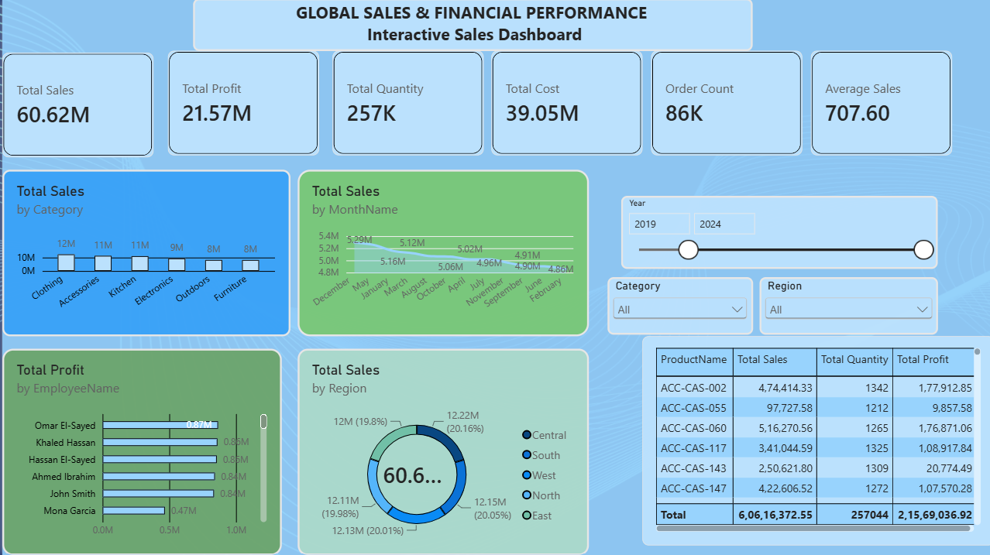
The Interactive Sales Dashboard above brings together six headline KPI cards (Total Sales, Total Profit, Total Quantity, Total Cost, Order Count, and Average Sales) with five supporting visuals: Total Sales by Category, Total Sales by Month Name, Total Profit by Employee Name, Total Sales by Region, and a detailed product-level table. A Year slider (2019–2024) and Category and Region dropdown filters let users drill into specific slices of the business, making the dashboard a single, interactive view of overall company performance.

4. KPI Analysis
The six top-level KPI cards summarize the overall health of the business:
Total Sales  60.62M | Total Profit  21.57M | Total Cost  39.05M
Total Quantity  257K | Order Count  86K | Average Sales  707.60

- Overall profit margin: Total Profit ÷ Total Sales ≈ 21.57M ÷ 60.62M = 35.6%, indicating a healthy margin on revenue generated.
- Cost ratio: Total Cost represents about 64.4% of Total Sales, which is consistent with the profit margin above and suggests cost control is reasonably stable.
- Average Sales of 707.60 per order is consistent with Total Sales ÷ Order Count (60.62M ÷ 86K ≈ 705), confirming the KPI figures are internally consistent.
- With 257K units sold across 86K orders, the average order carries roughly 3 units, suggesting most transactions are small-basket purchases rather than bulk orders.

5. Product Category Performance Analysis
The “Total Sales by Category” chart ranks six categories from highest to lowest revenue: Clothing (~12M), Accessories (~11M), Kitchen (~11M), Electronics (~9M), Outdoors (~8M), and Furniture (~8M).
- Clothing is the strongest category, generating the highest total sales, followed closely by Accessories and Kitchen — together these three categories form the backbone of company revenue.
- Electronics sits in the middle of the pack, while Outdoors and Furniture are the weakest performers, each trailing the top category by roughly a third.
- The product-level table reinforces this pattern at the SKU level: products such as ACC-CAS-060 (516K in sales) and ACC-CAS-002 (474K in sales) are strong performers with healthy profit contributions (176K–178K), while ACC-CAS-055 and ACC-CAS-143 generate comparable or even higher sales volume but disproportionately low profit (under 21K each), pointing to a margin problem rather than a demand problem for those specific SKUs.

6. Monthly Sales Trend Analysis
The “Total Sales by Month Name” line chart shows a gently declining trend when months are read from December through to February, moving from a peak of roughly 5.29M down to a low of roughly 4.86M.
- December stands out as the strongest month, consistent with seasonal, holiday-driven demand.
- Sales taper gradually through the winter and spring months, with February representing the softest point on the chart.
- The relatively narrow band between the highest and lowest months (about 5.29M vs 4.86M, an 8% spread) indicates demand is fairly stable year-round, with only a modest seasonal lift rather than extreme spikes or troughs.

7. Regional Sales Analysis
The “Total Sales by Region” donut chart shows an unusually even split of the 60.6M total across five regions: Central 12.22M (20.16%), North 12.15M (20.05%), West 12.13M (20.01%), South 12.11M (19.98%), and East 12.00M (19.80%).
- No single region dominates — the spread between the highest (Central) and lowest (East) region is less than half a percentage point, showing a well-diversified geographic footprint.
- East is the only region trailing the 20% mark, making it the most natural candidate for targeted growth initiatives without materially affecting other regions.
- Because performance is so evenly distributed, regional risk is low: the business is not overexposed to any single geography.

8. Employee Performance Analysis
The “Total Profit by Employee Name” chart ranks six employees by profit contribution: Omar El-Sayed (0.87M), Khaled Hassan (0.85M), Hassan El-Sayed (0.85M), Ahmed Ibrahim (0.84M), John Smith (0.84M), and Mona Garcia (0.47M).
- Omar El-Sayed is the top performer, though the gap between the top five employees is narrow — all five sit within roughly 0.03M of each other.
- Mona Garcia's profit contribution (0.47M) is markedly lower — about 46% below the top performer — making this the most notable outlier in the dashboard.
- The tight clustering among the top five suggests a consistent, well-performing core sales team, while the gap for the lowest performer points to a specific coaching or support opportunity rather than a team-wide issue.

9. Business Recommendations

Inventory Planning
- Increase stock levels ahead of the December peak season and scale back slightly for the February trough to avoid overstocking during the slower period.
- Prioritize inventory investment in Clothing, Accessories, and Kitchen — the three categories driving the majority of sales.

Marketing Strategy
- Run targeted promotions from January through March to counteract the seasonal dip identified in the monthly trend analysis.
- Use the strong December performance as a template for holiday campaigns in future cycles, and extend similar promotional pushes to Outdoors and Furniture to lift their comparatively weaker sales.

Regional Expansion
- Since all five regions contribute close to an equal 20% share, expansion investment can be spread evenly; however, the East region (19.8%) is a reasonable first target for incremental growth campaigns.
- Replicate the operating practices of the top region (Central) in other regions, since the performance gap is small and likely addressable with process alignment.

Employee Performance
- Recognize and study the approach used by Omar El-Sayed and the other top performers to create a best-practice playbook for the wider team.
- Provide targeted coaching, mentoring, or resource support to Mona Garcia to close the performance gap with the rest of the team.

Product Portfolio
- Review pricing and cost structure for low-margin, high-volume SKUs such as ACC-CAS-055 and ACC-CAS-143, where profit is disproportionately low relative to sales and quantity sold.
- Consider phasing out or repositioning consistently weak categories (Outdoors, Furniture) if margin improvements cannot be achieved, or bundle them with top-selling categories to boost movement.

Customer Targeting
- Use the average order value (707.60) as a benchmark to design upsell and cross-sell offers that nudge customers above this threshold.
- Target marketing toward customers who purchase in top-performing categories (Clothing, Accessories, Kitchen) with personalized offers, since these categories show the strongest existing demand.

